Ilayda Hanci
Due 21 October, 2016
DADA
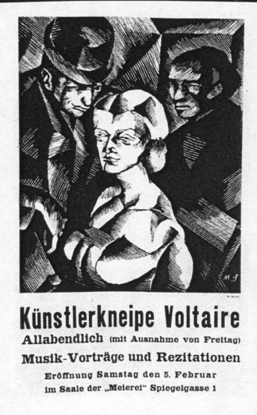
Zurich
Many of the ideas that characterized Dada as a movement, grew out of events that took place in Zurich. For the opening of the Cabaret Voltaire, Marcel Slodki did a poster for the opening day. All artist of Zurich was invited to make contributions off all kinds.
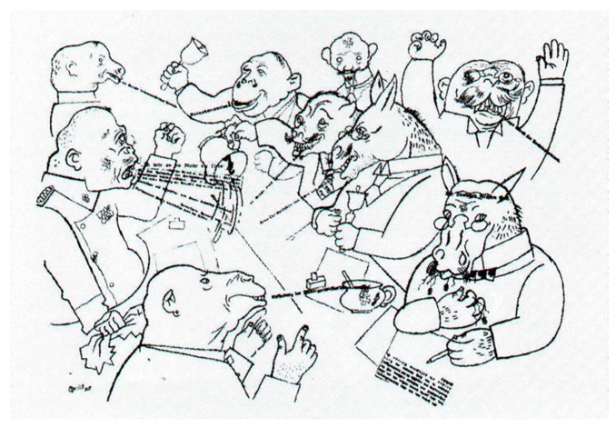

Berlin
The groups in Germany were not as strongly anti-art as other groups. Their activity and art were more political and social, with corrosive propagandas, satire, public demonstrations and political activities. The intensely political and war environment of Berlin had a dramatic impact on the ideas of Berlin Dadaists.
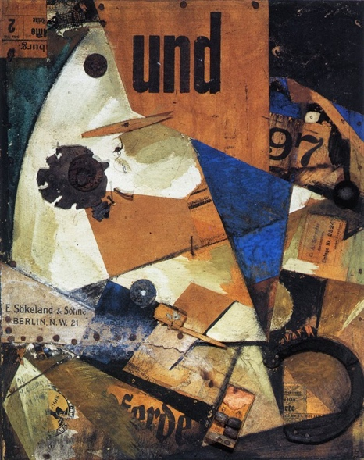

Hannover
The artists engage the theme of modernism in a more equivocal manner that suggests anxiety by making collages. As in so many other works of this period, the anxiety about a rapidly transforming culture is the hidden concept of the collages.

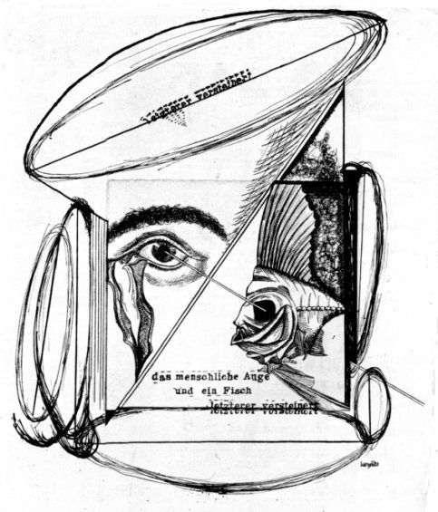

Cologne
The Cologne movement was less political and more biased towards aesthetics. The artists exploited satirical collage techniques using popular printed material, depicting the grotesque and the weirdly erotic.

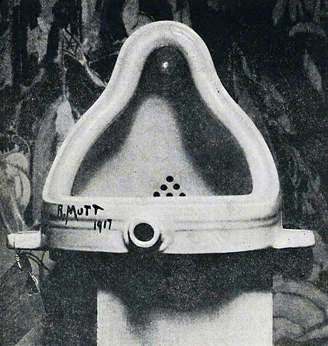
Marcel Duchamp, Fountain,1917

New York
New York's geographic distance from the war spawned its more theoretically-driven, less political nature. The artists in New York, didn’t issued manifestos. They issued challenges to art and culture through publications. New York Dada was driven by a sense of irony and humor.

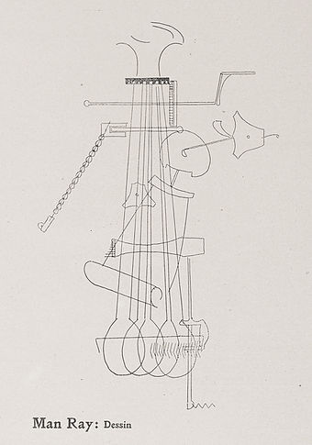
Paris
Paris Dada became noted for its theatrical, multi-cultural,
musical activities.

